# Homework Assignment: Cryokinetic Linux Challenge

Or, Candy Cane Striper Challenge

Access this challenge through the Cryokinetic Magic. This challenge teaches you about the execute permission in the basic Linux file system (remember rwxrwxrwx?) You’ll need to know about the change mode command, chmod, which sets file permissions. Your job will be to execute a file that does not have the execute permission, and how to work around the loss of the chmod command.

The terminal is sitting on top of the fishing hut.



Holly Evergreen needs you to start the CandyCaneStriper process. If you run ls -l, you’ll see that the file no longer has the execute permission.

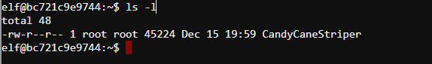

# Some Hints

Holly thinks someone has been mucking about with her machine, and the chmod program. 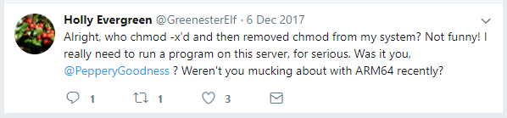

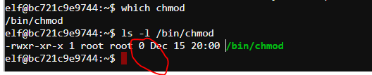

Uh-oh. The file size of the chmod application is 0 bytes. Not good.

You need to figure out how to run an executable without the execute permission, or find another way to chmod the file.

The way I found was to do chmod with Python. You can run Python interactively this way. 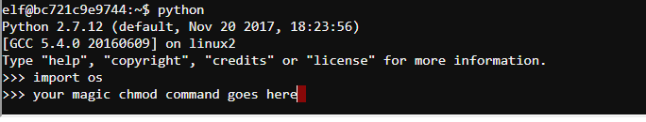

Note: you have to own the file to chmod it, and you don’t own CandyCaneStriper. If you had your own copy, though, you would own the copy.

Bonus points if you figure out a way to run the executable directly, as I didn’t…

# Questions

1. Submit a screen shot of your solution
2. Submit a brief description of how it works.